**Car Rent Incorporation**



**Worldwide Car Renting Company**

**Participants** – Viktor Kavaldzhiev, Stoicho Chakarov, Kaloyan Dimov

**Manager** – Bozhidar Dimitrov

**Purpose of the project** – Our purpose of the project is to create company for purchasing and renting cars. Through our project it will be way more easier for people to decide which car they want to rent, because there is easier accessibility of information for every each car and which cars are able for rent. The goal is to achieve perfection of our program and help many other companies.

**Диаграма на програмата**

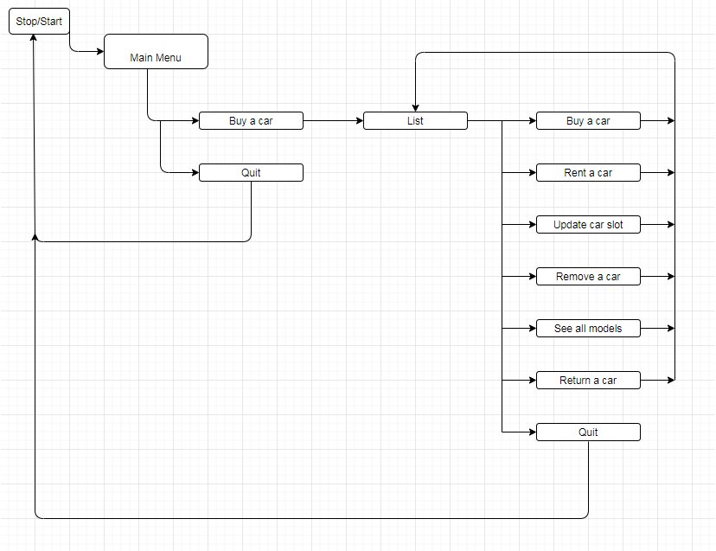

|  |  |  |  |
| --- | --- | --- | --- |
| Functions | Description | Arguments | Return Value |
| Create() | Adds a new car to the list of cars | CAR* cars,int& size,string plateNum,string model,string colorWay, string manufactureDate,int kilometers,char condition,float score,float prize | “Bool” function, returns true or false, depending on the success of the function |
| Update() | There are four different update functions available, each designed to change a particular field in the structure | CAR* cars, int/char/string/float value , int i, string stat | “Bool” function, returns true or false, depending on the success of the function |
| Remove() | Removes a car from the car list | CAR* cars, int& size, int index | Empty function |
| Return() | Changes the field “rent” to its current state | CAR* cars, int index | “Bool” function, returns true or false, depending on the success of the function |
| Rent() | Changes the field “rent” to its current state | CAR* cars, int index | “Bool” function, returns true or false, depending on the success of the function |